Date: 25/06/21

INDEX

Sr no | Machine Name | Page No.
1 | Storage tank (5000ltr)
2 | Mixing tank (5000ltr)
3 | Storage tank (100ltr)
4 | Turn table 36"
5 | Automatic Airjet 6 head cleaning  machine
6 | Automatic six head filling machine
7 | Automatic Pick & place capping machine
8 | Automatic four head capping machine
9 | Shrink Table
10 | S- Conveyor
11 | Case Erector
12 | Driver Roller Conveyor
13 | Case Tapping Machine
14 | Idle Roller Conveyor
15 | Pick & Place Unit

- Turn Table 36”

We offer Turn Table that is fabricated using premium quality material and is efficient in working. Turn Table System for transfer or movement of various type of Bottles, Vials, Jars on any Liquid Filling Line. Turn Table can be used with any machine for collection or feeding of products and also used to change the total line direction for “L” shape or “U” shape movement of line. Turn Table is available in various diameter of 600, 750, 900 or 1200 mm. the range is also custom designed as required by the clients.

Turn Table can be supplied with Standard Variable Speed Pulley Drive or A.C. Variable Frequency Drive System for smoother Start and Stop operation for unstable products. Turn Table can also be made from
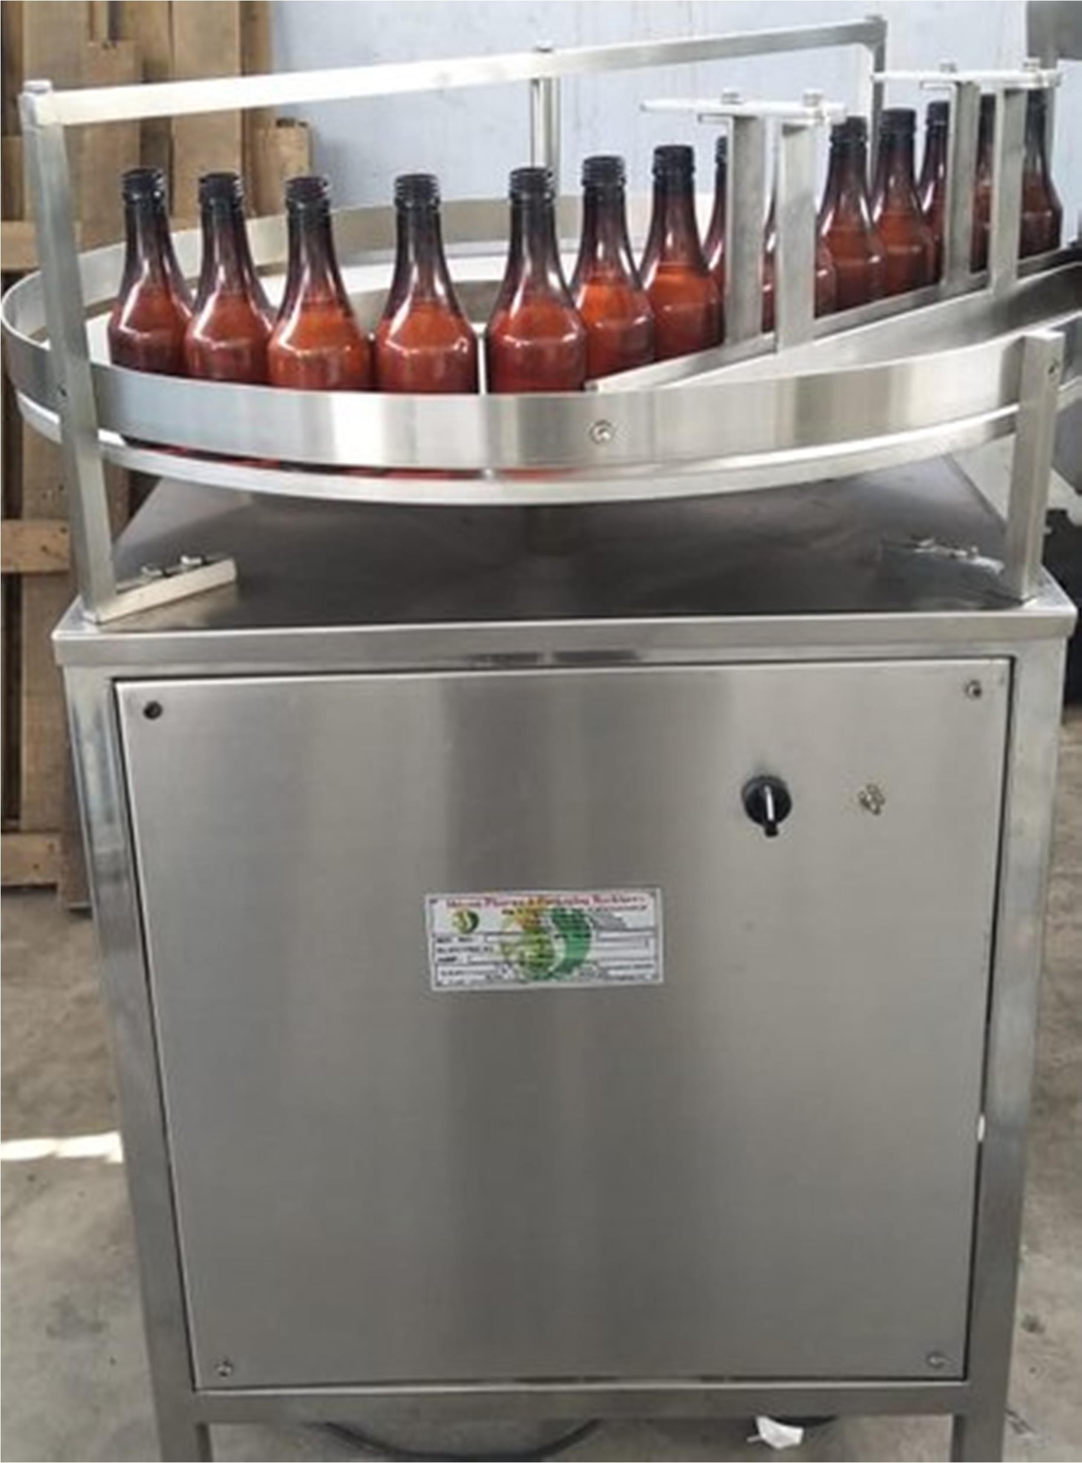
Stainless Steel Frame and also with Fully Stainless-Steel Top Plate on request.

Turn Table is also ideal for use in any automatic high speed liquid of powder line and turn table can also works as a buffer between two machines. If any of machines stop during the online operation, Turn Table can collect the outfeed product from machine or similarly can feed the products to machine without interrupting the complete line.
SALIENT FEATURE
All exposed parts are of S.S. to prevent rusting.
Reduction gear ensure jerk free & noise less performance & allows absolute cleanliness even inside.

Gear Motor: Nutech
A.C. Variable Frequency Drive: DELTA Make MACHINE SPECIFICATION

Direction: Left to Right
Power: 220 Volts, I Phase (2 Wire System) 50 Cycle/Second Output: 100 to 120 Product /Minute (Depending upon the production speed)
Motor: 0.5 HP.

- Air Jet Cleaning Machines

Our range of products include automatic four head air jet cleaning machine, vertical bottle air jet cleaning machine and linear tunnel type bottle air jet cleaning machine.

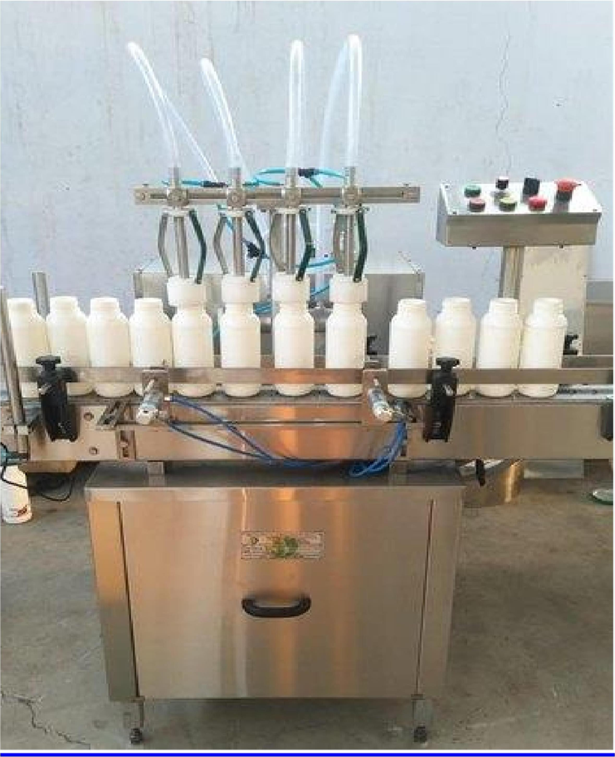

Product Details:

Minimum Order Quantity | 1 Unit
Machine Type | Automatic
Brand | NIHVA
Usage/Application | BOTTLE CLEANING
Head | 6 HEADS
Production Capacity | AS PER THE REQUIREMENTS
Model No | SACM-100
Output per Hour | 2400 to 7200
Direction of Movement | Left to Right
Motor Power | 0.5 HP/ 415 V/ 50 Hz
Blower Motor | 0.5 HP X 2= 2HP/ 415 V/ 50 Hz
Cleaning Cycle | Positive air Pressure and Vacuum Cleaning
Working Desk Height | 860 to 910 mm

With our vast experience and knowledge in this field, we are engaged in manufacturing a quality assured array of Automatic Air Jet Cleaning Machine.

Salient Features:

- Positive air pressure and vacuum cleaning
- Easy operation
- Stationary SS nozzles
- Automatic loading and unloading of container
- Individual control for air pressure and vacuum cleaning
- Higher capacity blower for proper cleaning
- SS Pressure met

- Automatic 6-Head Liquid Bottle Filling Machine

Suitable Bottle from 600ml
Output: 60-65 Bottles/Minute Depending on Filling Volume & Liquid viscosity

We will provide basic machine in complete stainless-steel finish with
One complete set of change parts (Syringe Set=6 Nos.) suitable for fill from 600ml.
(Total machine construction in S.S.-304 wherever; Contact parts is made from S.S.-304 material

Diving Nozzle System to prevent against foaming problems especially for Pesticide Liquid
Nozzle Lock System to Stop Dropping Problems. No Bottle – No Filling System
Built in A.C. Variable Frequency Drive system for speed control
Bottles with maximum speed of 60 to 65 Bottles per minute. The output of Bottle Filling Machines depending on nature of Liquids, Bottle Diameter, Bottle Height, Bottle Neck Size and Fill Volume. All parts coming in contact with Liquids are made from SS-316 Materials.
Machine construction in fully Stainless-Steel finish including machine
frame structure. Machine with

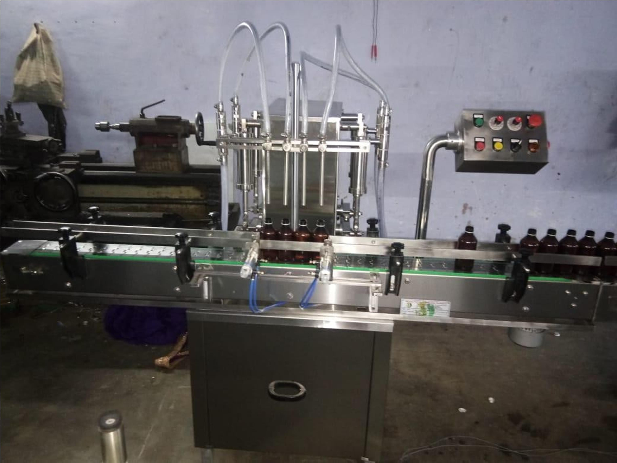

Optional Turn Tables at In-feed and Out-feed with individual drives to match the speed of incoming and outgoing Bottles for smoother operation. The Automatic Four Head Volumetric Linear Liquid Bottle Filling Machine.

MACHINE SPECIFICATION:

- Output: 60 to 65 Bottle/Minute (Depend on Filling volume, Nature of liquid & Bottle sizes)
- Power Characteristics: Single Phase / III Phase with A.C. Frequency drive.
- Dimension of Machine: 6” L X 3.5’’W

- Filling Accuracy: + 1% in single

- Dose Filling range: 600ml

Note: Change part will be charged extra to Fill from another volume.

A.C. Variable Frequency Drive: Danfoss Make
- Gear Box (Conveyor + Main): NUTECH
- Make Motor (Conveyor + Main): NUTEC
- Make Pneumatic Cylinder: AIRA Make

HIGHLIGHT OF THE MACHINE:

Total contact parts are of S.S.-304 and Other surface parts are of S.S.-304

Manufactured with latest technology

Synchronized two nos. A.C. drive for main motor & conveyor belt

Automatic speed control system.

No Bottle - No Filling systems.

Special Type Diving Nozzle to prevent against foaming problems especially for Pesticide liquid.

Nozzle Lock system to stop dropping problems.

Automatic sensor-based bottle counter system.

Bottle stopper and holder pneumatic based.

Rigid vibration free construction for trouble free performance $.3. Elegantly matt finished body.

Minimum change overtime, from one size to another fill size

Self-lubricating UHMW-PE guide profile for SS slat chain provides low friction wear surface, smooth and noiseless conveying.

Safety guard for conveyor gear box, motor and pneumatic cylinders Inbuilt protection against over current, Voltage fluctuation, Short circuit in

S.S. conveyor belt made from the S.S.-304 [Length: 6 Feet] Adjustable Conveyor height as per customer choice to align with another line machine.

Standard in quality & economical in price

- Automatic Pick & Place Inner Capping Machine

SUITABLE TO CAPPING YOUR PLASTIC CAPS
OUTUPT: 60-65 BOTTLES/MINUTE (Depending on Bottle/Cap Sizes)

We will provide basic machine in complete stainless-steel finish with
One complete set of change parts suitable for any one size Diameter of Caps & Bottle
Total machine construction in SS-304 wherever; Contact parts is made from SS-304 material

No Bottle – No Capping System Bottle Jam – Machine stop system.
Built in A.C. Variable Frequency Drive system for speed control.

MACHINE SPECIFICATIONS: -

Output: 60-65 Bottles/Minute (Depending upon the bottle size)
Powder characteristics: 440 Volts, III Phase (4 Wire system) 50Hz.
Machine Direction: Left to right

INPUT SPECIFICATIONS: -

Cap Dia: As per customer requirement (With the help of change parts.)
Change Parts Required to Change Bottle & Cap Dia.: Star wheel & Cap die EXTRA

HIGH LIGHT OF THE MACHINE
- No Bottle – No Capping System.
- Machine construction is Stainless Steel Finish.
- Cap orientation auto. Start/stop system.
- In feed & Exit sat wheel with over load clutch system to avoid bottle breakage.
- Single motor synchronizes conveyor, star wheel & platform turret.
- Minimum change over time.
- Pick & place arrangement.
- Hopper can be completed dismantled for easy cleaning.
- Adjustable height conveyor belt.
- Low noise level & low power consumption.
- Standard in quality & Economical in price.

- Automatic Four Head Capping Machine

SUITABLE TO CAPPING YOUR CAPS
OUTUPT: 60-65 BOTTLES/MINUTE

(Depending on Bottle/Cap Sizes) We will provide basic machine in complete stainless-steel finish with

One complete set of change parts suitable for any one size Diameter of Caps & Bottle
Total machine construction in SS-304wherever; Contact parts is made from
SS-304 material

No Bottle – No Capping System Bottle Jam – Machine stop system.Built in A.C. Variable Frequency Drive system for speed control

MACHINE SPECIFICATIONS: -
Output: 60-65 Bottles/Minute (Depending upon the bottle size)
Powder characteristics: 440 Volts, III Phase (4 Wire system) 50 Hz. Machine Direction: Left to right
INPUT SPECIFICATIONS: -
Cap Día: As per customer requirement (With the help of change parts.)

Change Parts Required to Change Bottle & Cap Dia: Star wheel & Cap dia WILL BE CHARGE EXTRA

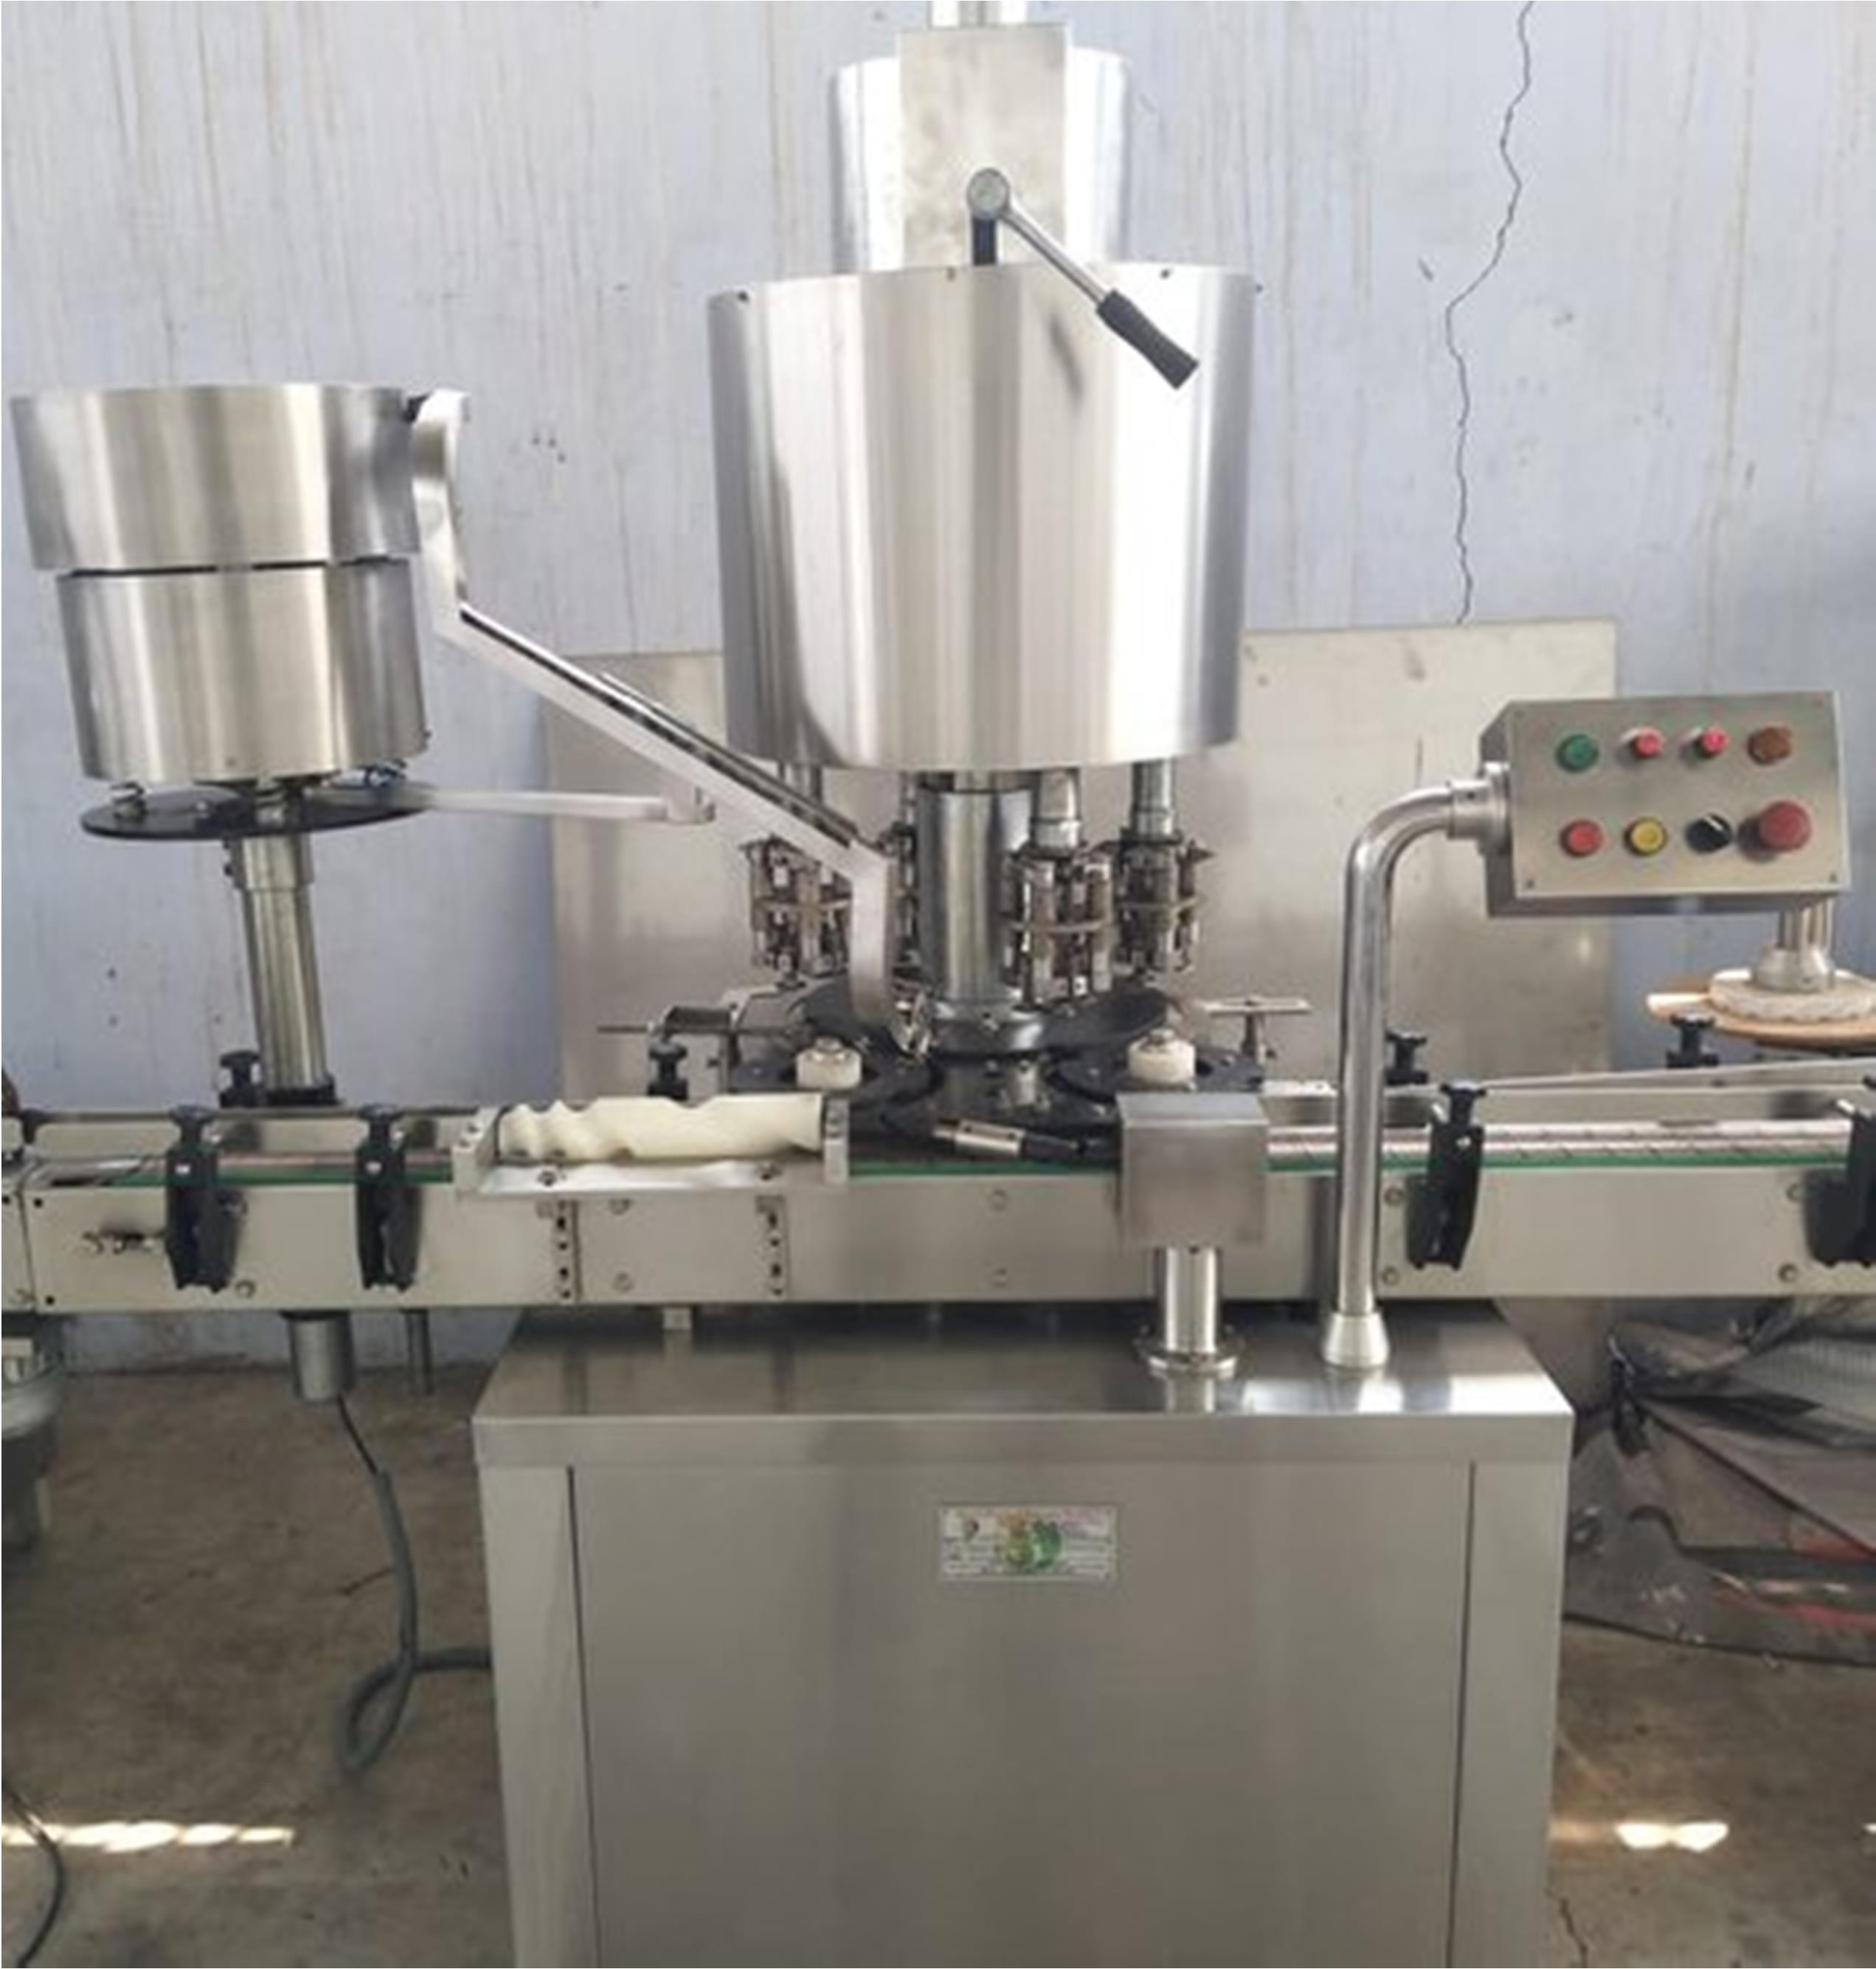

HIGH LIGHT OF THE MACHINE
- No Bottle – No Capping System.
- Machine construction is Stainless Steel Finish.
- Cap orientation auto. Start/stop system.
- In feed & Exit sat wheel with over load clutch system to avoid bottle breakage.
- Single motor synchronizes conveyor, star wheel & platform turret
- Minimum change over time. Pick & place arrangement.
- Hopper can be completed dismantled for easy cleaning.
- Adjustable height conveyor belt.
- Low noise level & low power consumption.
- Standard in quality & Economical in price.

- Shrink Tunnel
- S-Conveyor

  - It is one of the simplest conveyors.
  - It is used for conveying crates, box, pouches & bags.
  - It can be moved 90deg, 180deg, 270deg.
  - It can carry various products up to 100kg.
  - Size of the conveyor is designed as per the
  - Used in food & pharma industries.
  - Easy to clean & maintain.
  - Easy to replace belt as it is modular.

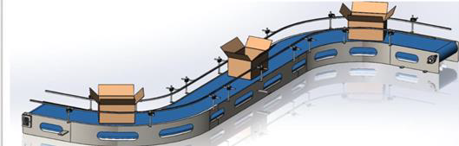

- Case Erector

- Case erector is used for forming of case blank to form case.
- Labeling of bottom tape.
- Size of the carton up to 600mm L x 500mm W x 400 mm H.
- No of carton /min-10 pc/min.
- Length, width and height is adjustable.
- Fully Automated Machine.
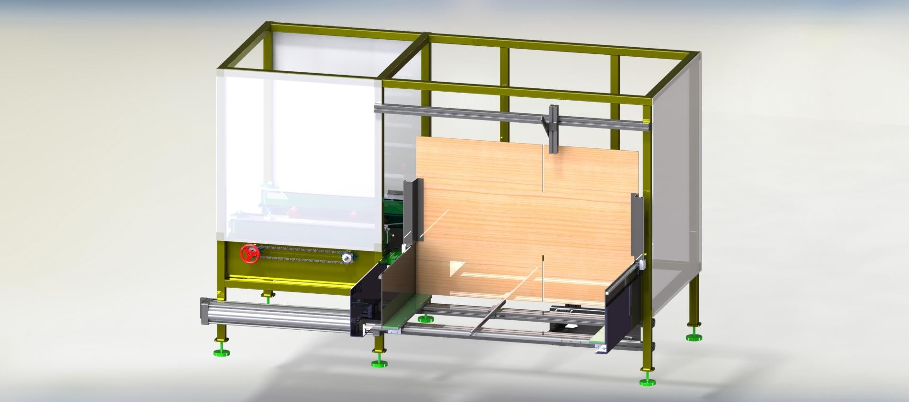

- Driver Roller Conveyor

- It is one of the drive roller conveyors.
- It is used in conveying crates & box in 90deg.
- It can carry various products up to 100kg.
- Size of conveyor is designed as per requirement.
- Used in different types of industries.
- Easy to clean & maintain.
- Easy to replace belt as it is modular.

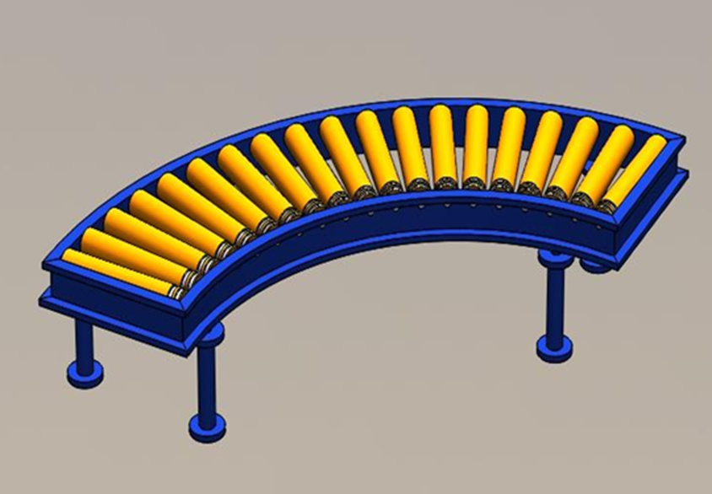

- Case Tapping Machine

- Case tapping is used for pasting of tape on top side of formed case.
- Labelling of top tape.
- Size of the carton up to 600mm L x 500mmW x 400 mm H.
- No of carton /min-10pc/min
- Length, width and height is adjustable.
- Fully automated machine.
- Width of tape 50mm, 75mm,100mm.
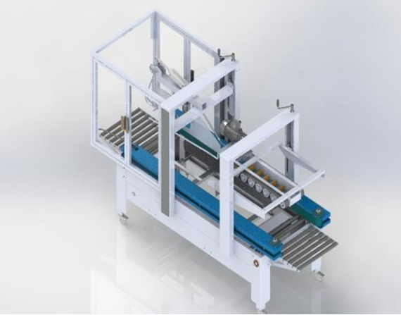
- Idler Roller Conveyor
- It is one of the gravity roller conveyors.
- It is used for conveying crates, box
- It can be moved 90 deg, 180 deg, 270 deg.
- It can carry various products up to 100 kg.
- Size of conveyor is designed as per requirement.
- For any industries we can use it.
- Easy to clean & maintain
- Easy is replace roller as it is modular.

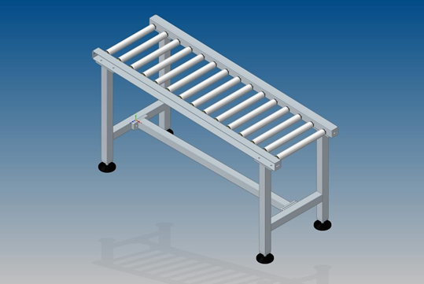

- Pick & Place Unit

- It is used for pick and place at X,Y&Z axis with rotation.
- It is used for Box, bag, bottle, tin & buckets.
- This is works on servo motors.
- Can be customized to any height to any weight.
- This is low cost and robust technology.

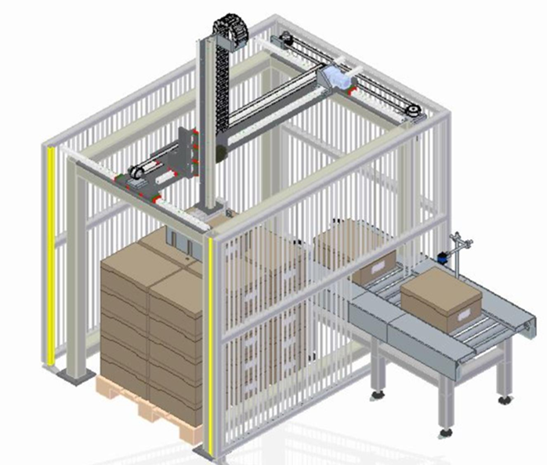
ro

